Lê Minh Thuận

DPM205488

DH21PM

Phần code

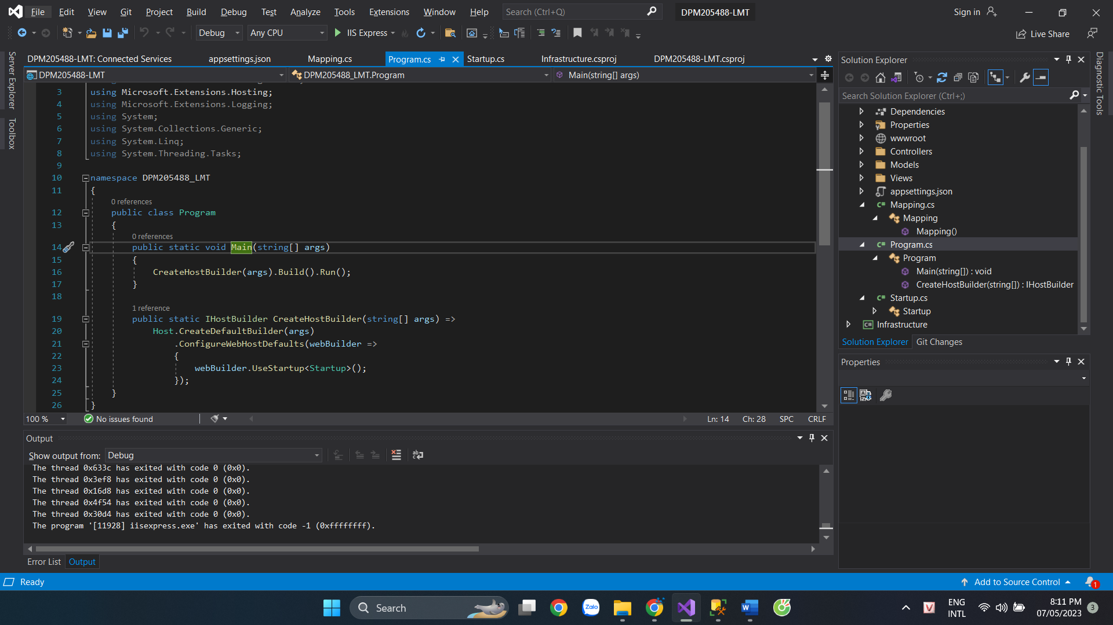

Khi chạy thì sẽ vào giao diện

Trang quản lí giày

Thêm giày

Xóa giày

